**CAP 276: DATA COMMUNICATION AND NETWORKING LABORATORY**

**CONTINUOUS ASSESSMENTS (C.A)-4**

**ST_NAME: - EKHLAKH AHMAD**

**REG NO.: - 12209166**

**ROLL NO.: - RD2215B67**

**SECTION: - D2215**

**GROUP: - 2**

**Q.1. configure HTTP server and demonstrate the process to access a website using IP address in real-time and simulation mode.**

**Process: -**

* Open Cisco Packet Tracer.
* Select two PC and draw black area.
* And assign IP Address both PC.
* Select Switch and draw blank area.
* Select Server and assign IP address.
* 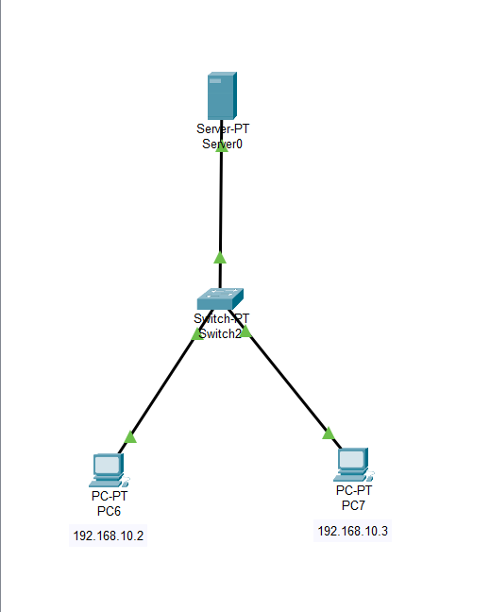Connect with automatically wired to each other PC to Switch and Switch to PC.

**Q.2. configure DNS server for two domain names with two HTTP servers in the networks and demonstrate the process to access both the servers using name resolution in real time and simulation mode.**

**Process:**

* Open Cisco Packet Tracer.
* Select one PC and draw blank area.
* Select one Switch and draw blank area.
* Select two server and draw blank area.
* Select automatically wire and connect each other
* PC to Switch and Switch to both servers.
* Assign IP address and Gateway address

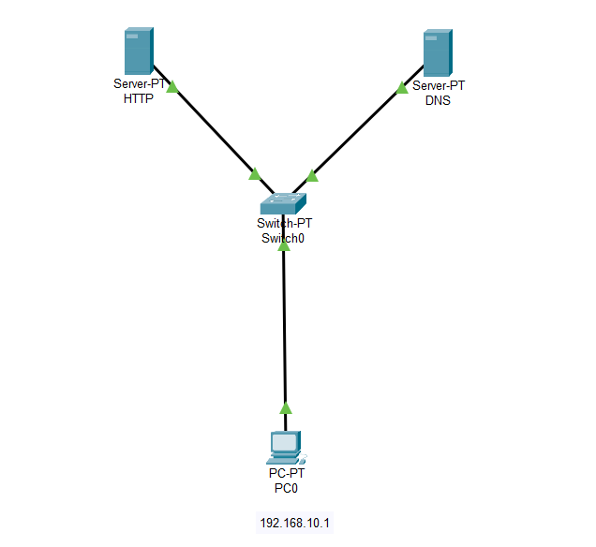

**Q.3. connect two or more networks with DHCP Server**

**Process:**

* Open Cisco Packet Tracer.
* Select two or more PC and draw blank area.
* Select one Switch and draw blank area.
* Select one server and draw blank area.
* Select automatically wired and connect to each other.
* Assign IP address in Server.
* Click on DHCP.

